# A primer in machine learning

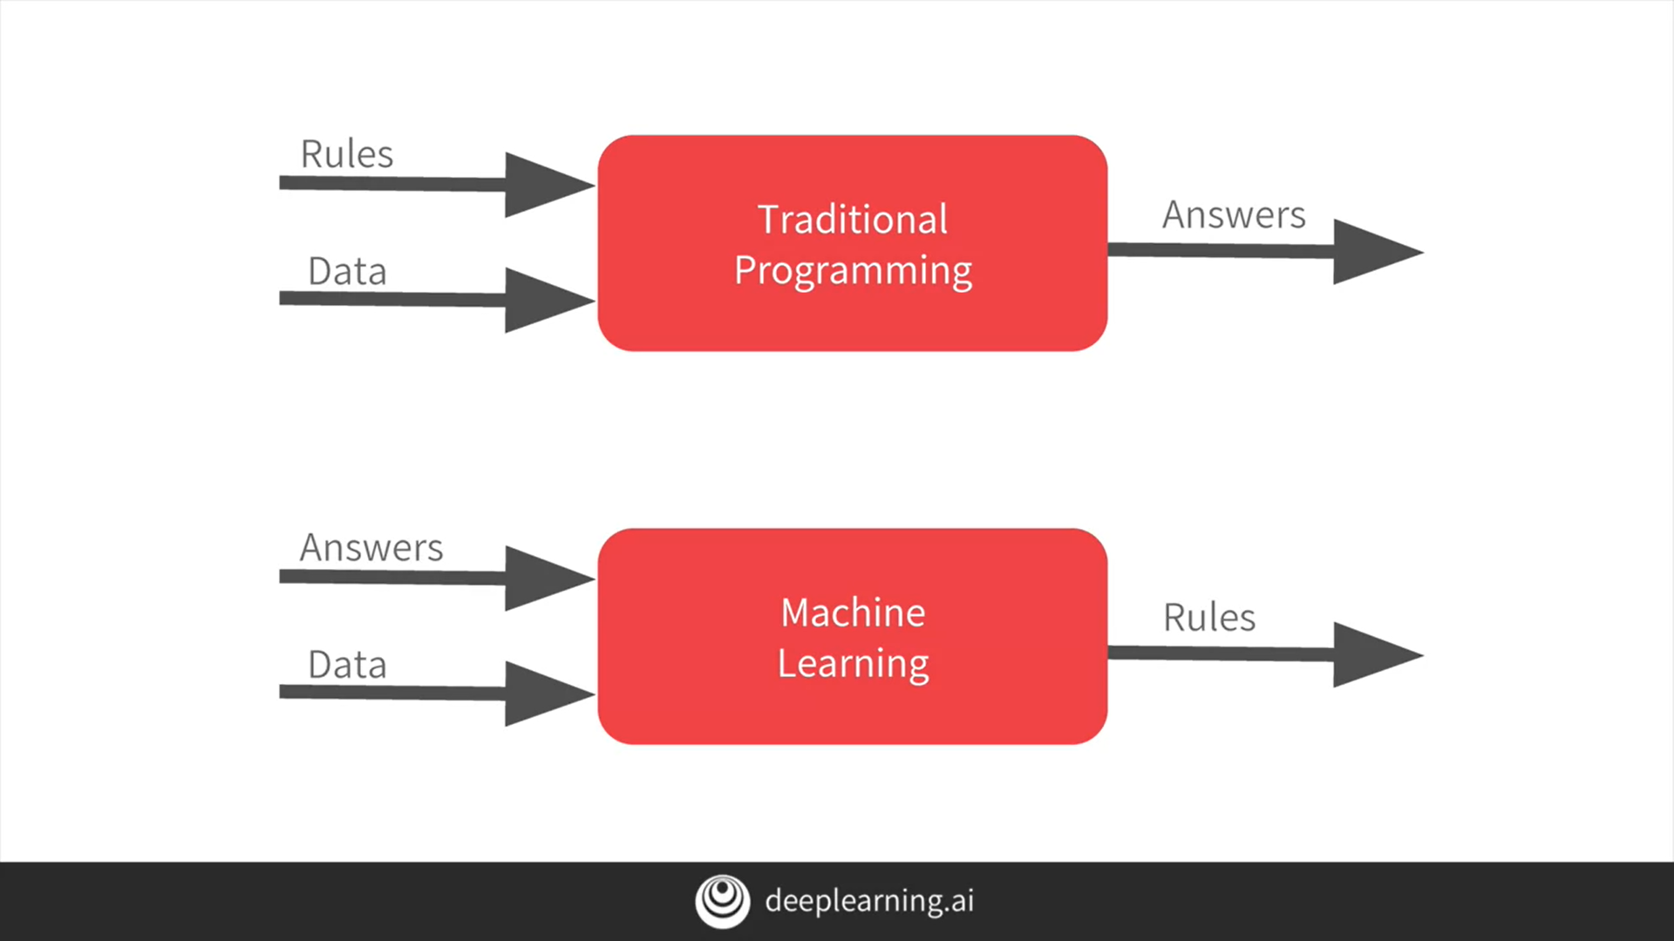

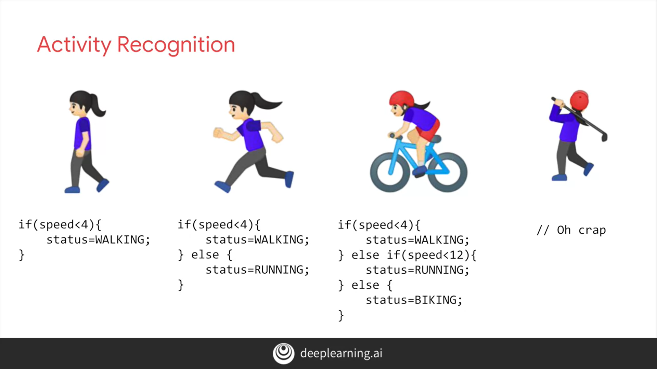

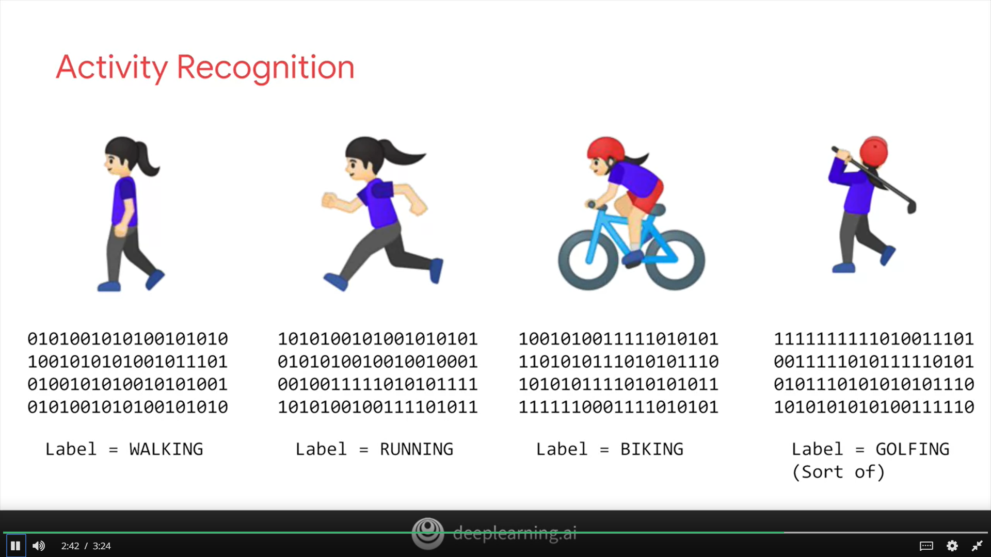

# The ‘Hello World’ of neural networks

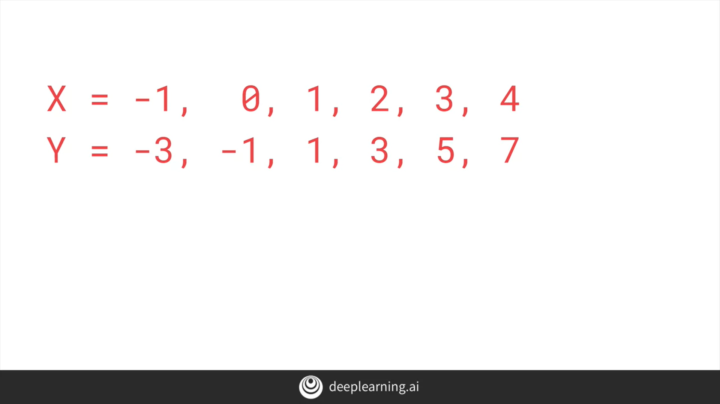

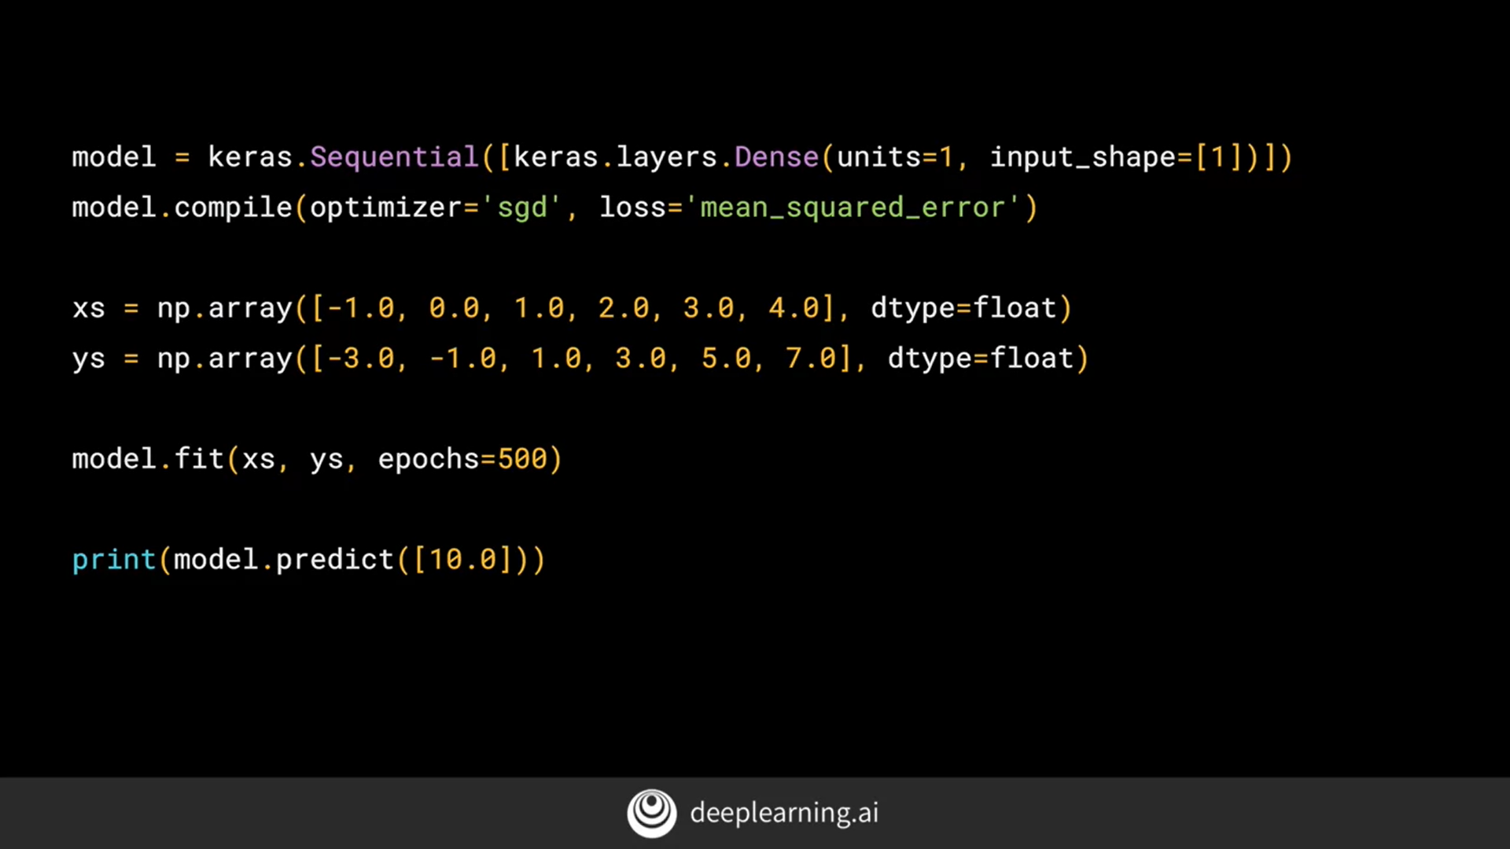

# Working through ‘Hello World’ in TensorFlow and Python

**import** **tensorflow** **as** **tf**

**import** **numpy** **as** **np**

**from** **tensorflow** **import** keras

model = tf.keras.Sequential([keras.layers.Dense(units=1, input_shape=[1])])

model.compile(optimizer='sgd', loss='mean_squared_error')

xs = np.array([-1.0, 0.0, 1.0, 2.0, 3.0, 4.0], dtype=float)

ys = np.array([-3.0, -1.0, 1.0, 3.0, 5.0, 7.0], dtype=float)

model.fit(xs, ys, epochs=500)

print(model.predict([10.0]))

Link to github - <https://github.com/vinayakvaid/dlaicourse/blob/master/Course%201%20-%20Part%202%20-%20Lesson%202%20-%20Notebook.ipynb>